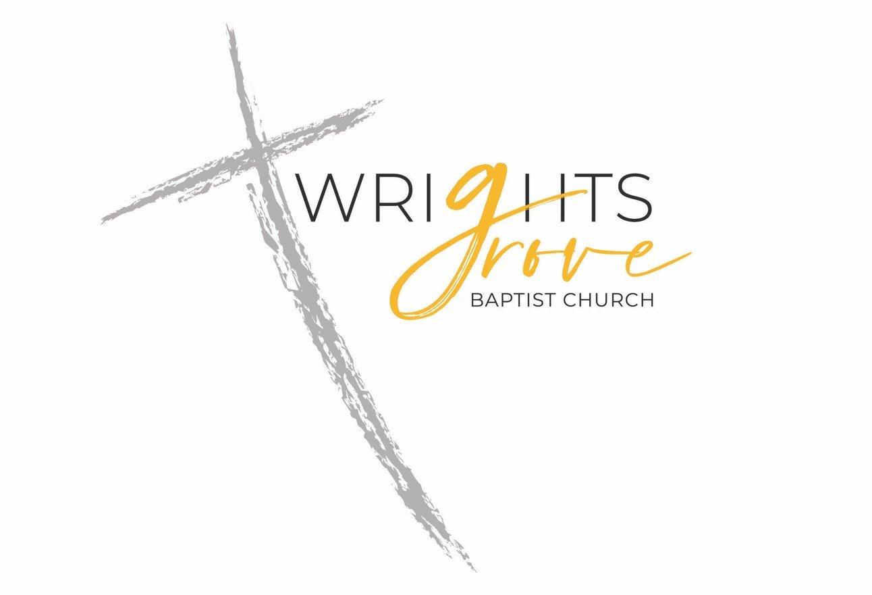
WRIGHTS GROVE BAPTIST CHURCH
Brand Guidelines
Visual identity, voice, and standards
✦
"For God is not the author of confusion, but of peace."
— 1 Corinthians 14:33
VERSION 1.0
May 2026

01 · BRAND ESSENCE
Who We Are
Wrights Grove Baptist Church is a community of believers grounded in scripture and shaped by service. We are a working church — neighbors who show up, hands that build, voices that praise. Our brand should sound and feel like the church does on a Sunday morning: warm, unhurried, and honest.

What We Stand For
Faith over flash. We don't chase trends. The cross on our logo is the same cross that's been on our wall for generations. Our visual identity should feel rooted, not branded.
Welcome before instruction. First-time visitors and lifelong members both deserve to feel at home. Every piece of communication — from a sign to a newsletter — should make someone feel invited, not lectured.
Plain speech. We write the way we'd talk to a neighbor on the porch. No jargon. No corporate church-speak. If a child can understand it, we've done it right.
Service is the point. Six ministries, a printed newsletter every Sunday, a YouTube channel, and dozens of volunteers — we are a church of doers. Our communications should reflect that quiet competence.

How to Use This Guide
This document is a working reference, not a rule book. Pages 3 through 5 cover the visual and verbal standards — logo, color, type, and voice. Share it with anyone helping us communicate: designers, sign vendors, printers, volunteers, social media helpers. When in doubt, the question to ask is simple: does this feel like Wrights Grove?

02 · VISUAL IDENTITY
The Logo
Our logo pairs a hand-drawn cross with the church name set in two voices — a steady serif and a flowing script — anchored by the words "Baptist Church." Together they speak to who we are: rooted but warm, traditional but personal.
Primary logo — full color on white

Logo Usage
- Always preserve the original proportions. Never stretch, squish, or rotate.
- Maintain clear space equal to the height of the word "BAPTIST" on all sides of the logo.
- Minimum size: 1 inch wide for print, 120 pixels wide for digital. Below that, the script becomes unreadable.
- Use on white or cream backgrounds whenever possible. For dark backgrounds, ask for a reversed version (see note below).
- Do not place the logo over busy photography. If a photo background is unavoidable, place it on a solid color block.

A NOTE ON LOGO FILES
Our current logo exists only as a flat PNG/JPG on a white background. For vendor work — banners, embroidered shirts, signage, large-format print — we will need to source the original vector files (SVG, AI, or EPS) and a transparent-background PNG from the original designer. Until those exist, please flag any vendor project that needs to scale beyond 8 inches wide so we can address it before production.

03 · VISUAL IDENTITY
Color & Type

Color Palette
GROVE GOLD
HEX #E8A93C
RGB 232, 169, 60
CMYK 4, 32, 80, 0
Primary accent. Use for headlines, dividers, and key emphasis. Sparingly — it should feel like sunlight, not paint.

CROSS CHARCOAL
HEX #2B2B2B
RGB 43, 43, 43
CMYK 0, 0, 0, 83
Primary text color. Used for body copy, headings, and the logotype. Pure black is too harsh; charcoal carries the same gravity with more warmth.

SANCTUARY CREAM
HEX #FAF6EF
RGB 250, 246, 239
CMYK 0, 2, 5, 2
Background tint for forms, callouts, and printed pieces. Adds warmth without competing with the gold. Avoid pure white when paper or screen feels cold.

SOFT STONE
HEX #5A5A5A
RGB 90, 90, 90
CMYK 0, 0, 0, 65
Secondary text. Captions, dates, subheadings, and supportive copy that shouldn't compete with the main message.

TYPOGRAPHY

Type System
Our typography is intentionally simple. The logo carries the personality; the body type should disappear into readability.
PRIMARY TYPEFACE
Calibri
Universal availability. Works on every computer, phone, and printer without installation. Use Calibri Bold for headings and Calibri Regular for body copy.
PROFESSIONAL ALTERNATIVE
Source Sans Pro
For designers and vendors working on materials in Adobe or other professional tools — Source Sans Pro is free, open-source, and reads similarly to Calibri at larger sizes.

Type Hierarchy
Section Header — 26pt Bold Charcoal
Subhead — 22pt Bold Charcoal
Body copy — 22pt Regular Charcoal. The main reading size for newsletters, forms, and printed materials.
Caption / supporting text — 18pt Italic Stone
EYEBROW LABEL — 16PT BOLD GOLD, TRACKED OUT

04 · VERBAL IDENTITY
Voice & Tone
How Wrights Grove sounds in writing — whether it's a Sunday newsletter, a Facebook post, a contact form auto-reply, or a sign on the door.

Our Voice
Warm, not slick. We are a neighborhood church, not a marketing campaign. Our writing should feel like a real person wrote it.
Direct, not stiff. Short sentences. Active voice. Say what you mean. "Bible study meets Wednesday at 7" beats "please be advised that Bible study will commence on Wednesday evenings at the appointed hour of 7:00 PM."
Inviting, not pushy. We open the door. We don't drag anyone through it. Use "you're welcome to join us" rather than "don't miss this opportunity."
Reverent, not stuffy. Scripture, theology, and sacred topics are handled with care. But that doesn't mean every sentence needs to sound like the King James Version.

In Practice
INSTEAD OF  Please be advised that the Wrights Grove Baptist Church will be hosting its annual community outreach initiative on Saturday morning. | TRY  Join us Saturday morning for our annual community outreach. We'd love to have you.

INSTEAD OF  We are seeking new members to participate in our esteemed Praise & Worship Ministry. Auditions will be held following the conclusion of the 11:00 AM service. | TRY  Our Praise & Worship team is welcoming new voices. Come find us after the 11 AM service — no audition pressure, just a quick hello.

INSTEAD OF  Your inquiry has been received. A representative will respond within 2-3 business days. | TRY  Thanks for reaching out. Someone from our team will be in touch within a few days.

✦
When in doubt, write the way you'd talk to a neighbor on the porch.

